

Data Visualization of Bird Strikes between 2000 – 2011

KRITIKA SHARMA | DATA SCIENCE | MARCH 11, 2024

# **PROBLEM STATEMENT**

Transport and communication are in the crucial domain in the field of analytics. Environmental impacts and safety are, nowadays, two major concerns of the scientific community with respect to transport scenarios and to the ever-growing urban areas. These issues gain more importance due to the increasing amount of vehicles and people. Seeking new solutions is reaching a point where available technologies and artificial intelligence, especially MAS, are being recognized as ways to cope with and tackle these kinds of problems in a distributed and more appropriate way. A bird strike is strictly defined as a collision between a bird and an aircraft which is in flight or on a take-off or landing roll. The term is often expanded to cover other wildlife strikes - with bats or ground animals. Bird Strike is common and can be a significant threat to aircraft safety. For smaller aircraft, significant damage may be caused to the aircraft structure and all aircraft, especially jet-engine ones, are vulnerable to the loss of thrust which can follow the ingestion of birds into engine air intakes. This has resulted in several fatal accidents. Bird strikes may occur during any phase of flight, but are most likely during the take-off, initial climb, approach and landing phases due to the greater numbers of birds in flight at lower levels.

# **INTRODUCTION**

# Brief overview of the project objectives and scope.

# Importance of analyzing bird strikes data for aviation safety

# **DATA COLLECTION & PREPROCESSING**

* **Source of the data (e.g., FAA database, aviation records).**
* **Description of the dataset's structure and variables.**
* **Preprocessing steps (e.g., handling missing values, data cleaning, feature selection).**

**Exploratory Data Analysis (EDA)**

Summary statistics of bird strike incidents.

Visualizations:

* Bar chart: Top 10 US Airlines with most bird strikes.
* Bar chart: Top 50 airports with most bird strikes.
* Line chart: Yearly cost incurred due to bird strikes.
* Histogram: Distribution of bird strikes by altitude.
* Pie chart: Phase of flight during bird strikes.

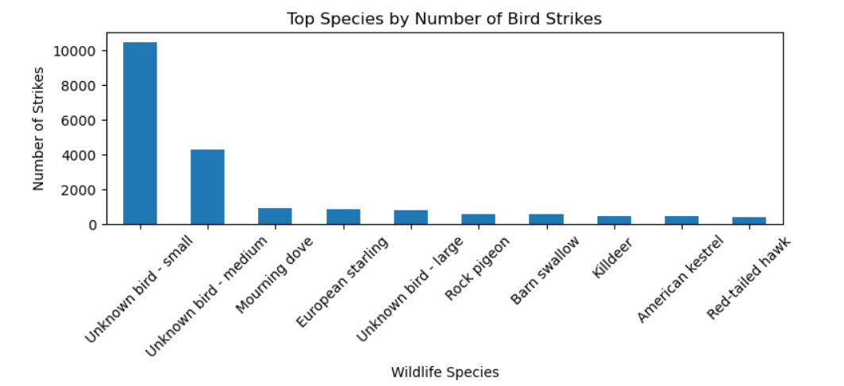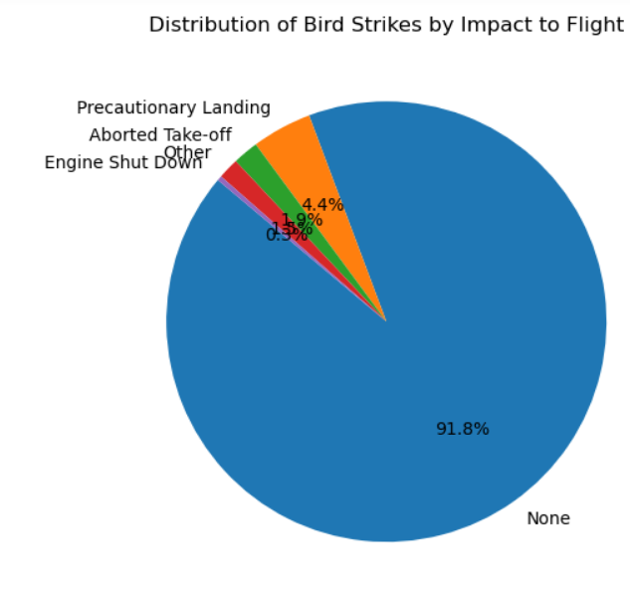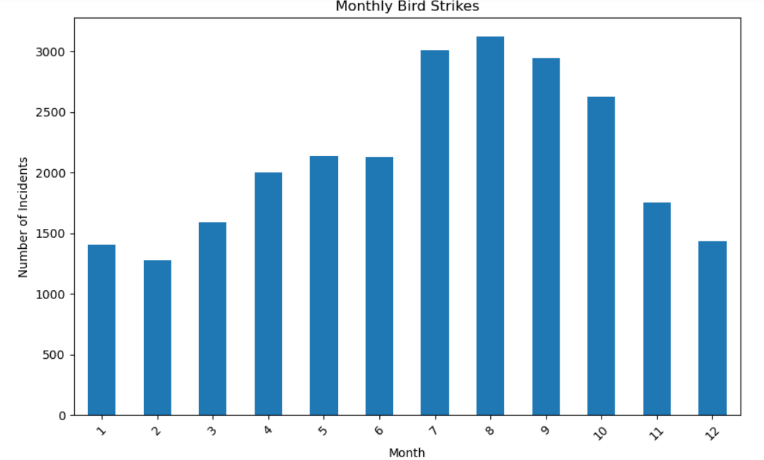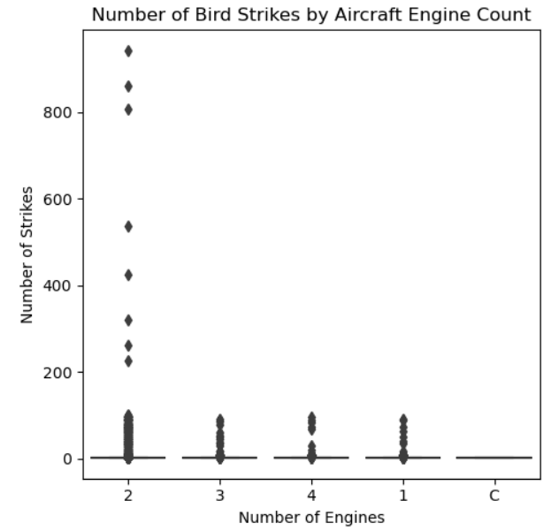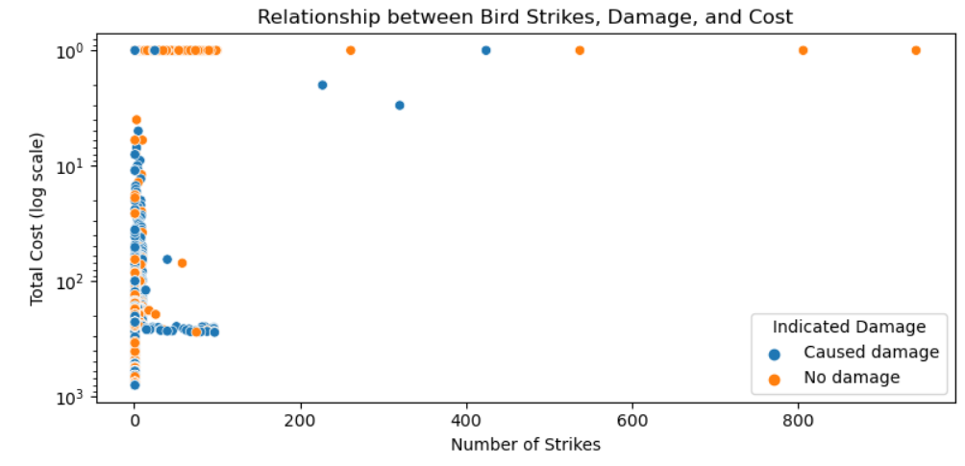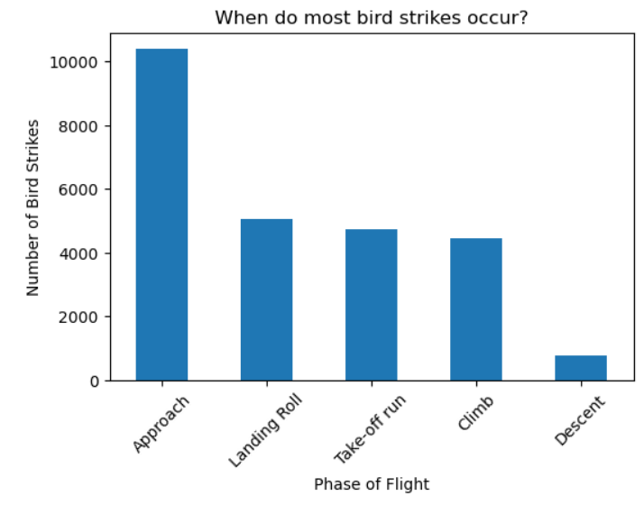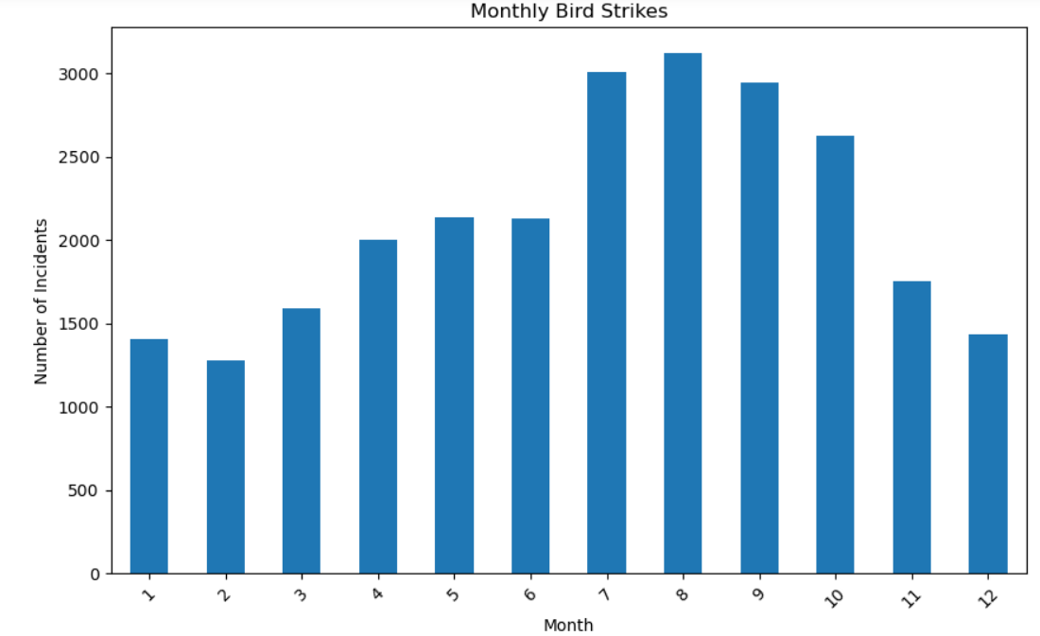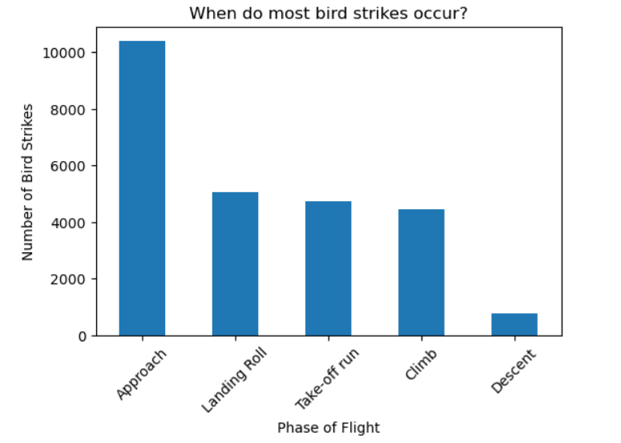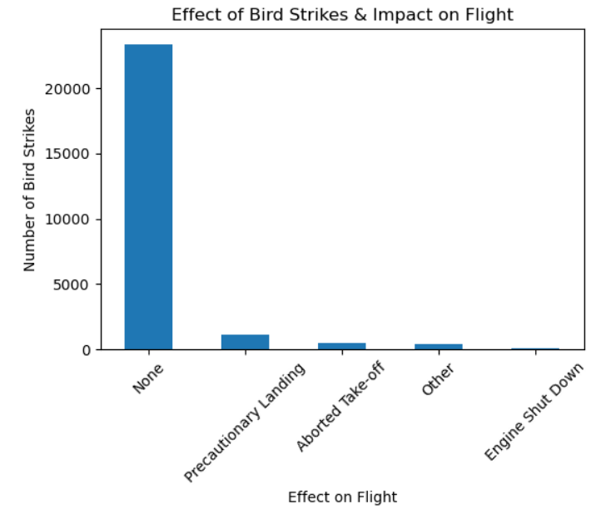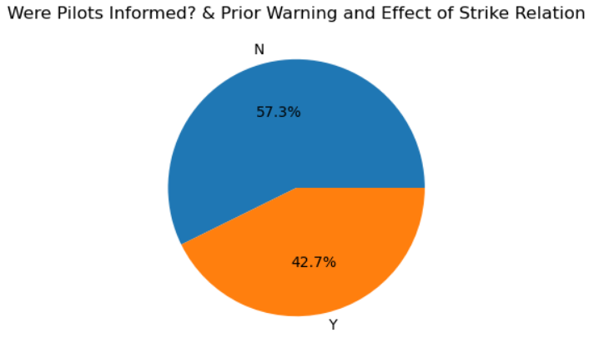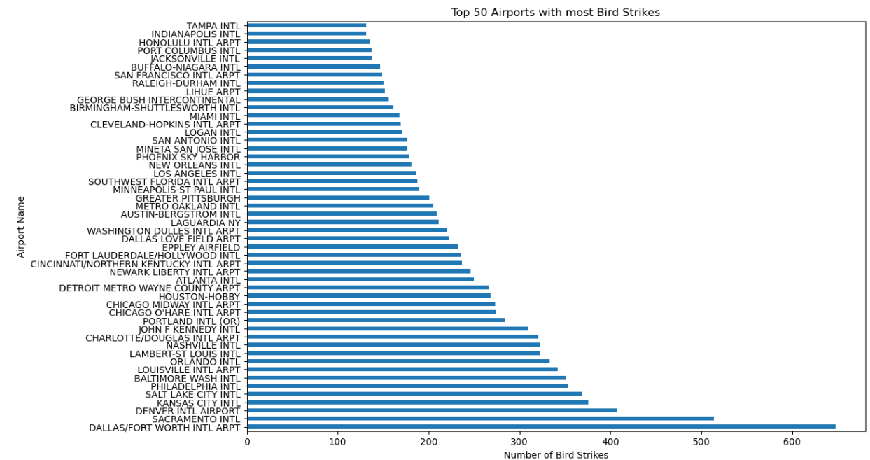

# **Key Insights and Findings**

# Identification of top US airlines and airports with the highest incidents of bird strikes.

# Analysis of yearly costs associated with bird strikes.

# Peak times and phases of flight when bird strikes occur most frequently.

# Altitude analysis and its impact on bird strikes.

# Effect of bird strikes on flight operations and safety measures.

# **Advanced Analytics**

# **Predictive modeling:**

# Machine learning models (e.g., logistic regression, decision tree) to predict bird strike occurrences.

# Evaluation metrics (accuracy, precision, recall) for model performance. {REFER PYTHON CODE}

# **Recommendations and Mitigation Strategies**

# **Suggestions for airlines and airports:**

# Implementing bird strike prevention measures.

# Enhancing pilot training and awareness.

# Improving aircraft design for bird strike resistance.

# **Conclusion**

# Summary of key findings and insights from the analysis.

# Implications of the analysis on aviation safety and risk management.

# **Future Research Directions**

Potential enhancements to the analysis methodology (e.g., real-time data integration, predictive analytics).